**Modul 3**

1. coba.php

Script

| 1. <html> 2. <head> 3. <title> Example </title> 4. </head> 5. <body> 6. ***<?php*** 7. echo "Hi, I'm a PHP script"; 8. ***?>*** 9. </body> 10. </html> |
| --- |

Screenshot script dan hasil output

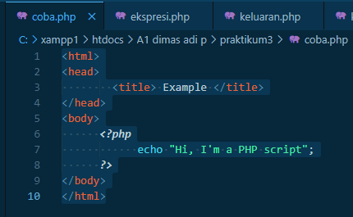

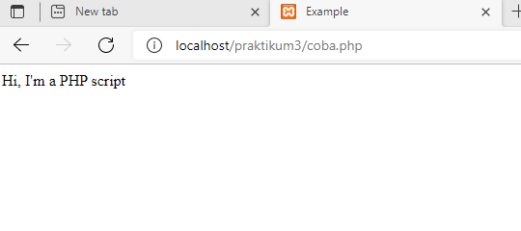

2. ekspresi.php

Script

| 1. <html>  2. <head>  3. <title> EKSPRESI </title>  4. </head>  5. <body>  6. ***<?php***  7. Print ((4**+**1**\***2)**.** "<BR> \n");  8. Print (((4**+**1)**\***2)**.** "<BR> \n");  9.  10. ***?>***  11. </body> |
| --- |

Screenshot script dan hasil output

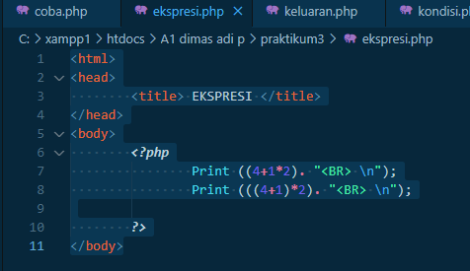

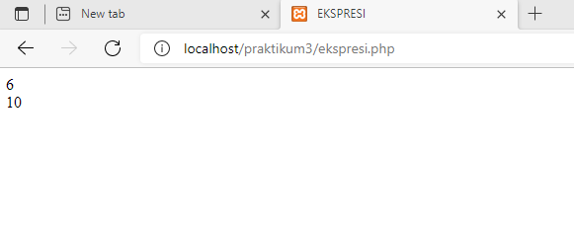

3. keluaran.php

Script

| 1. <html> 2. <head> 3. <title> Keluarannya </title> 4. </head> 5. <body> 6. ***<?php*** 7. echo "Hai,"**.**$_POST ["nama"]**.**"</br>"; 8. echo $_POST ["sekolah"]**.**"memang top"; 10. ***?>*** 11. </body> |
| --- |

Screenshot script dan hasil output

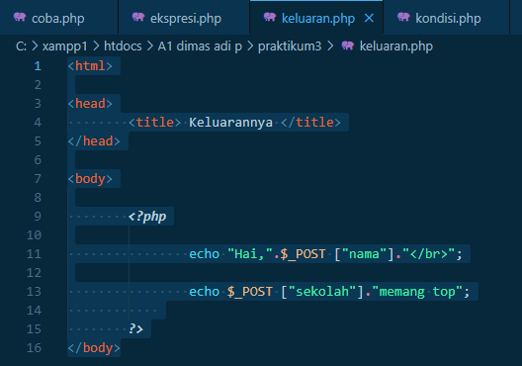

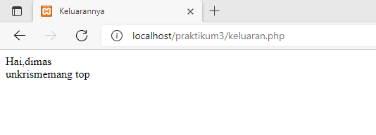

4. kondisi.php

Script

| 1. <html> 2. <head> 3. <title> Kondisional </title> 4. </head> 5. <body> 6. ***<?php*** 7. $Hari **=** date ("1"); 8. **if**($Hari**==**"Saturday") 9. { 10. Print ("Hari yang menyenangkan"); 11. } 12. **else** 13. { 14. Print ("Hari yang melelahkan"); 15. } 16. ***?>*** 17. </body> |
| --- |

Screenshot script dan hasil output

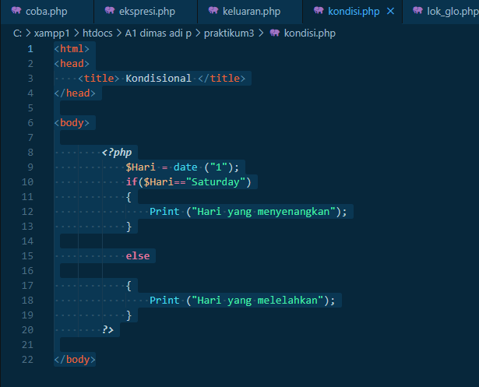

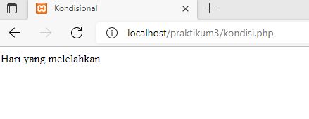

5. masukan.php

Script

| 1. <html> 2. <head> 3. <title> Masukan </title> 4. </head> 5. <body> 7. <FORM *ACTION*="keluaran.php" *METHOD*="post"> 8. Nama Anda : <BR> 9. <INPUT *TYPE*="text" *NAME*="nama"> <BR> 10. Kuliah di : <BR> 11. <INPUT *TYPE*="text" *NAME*="sekolah"> <BR> 12. <INPUT *TYPE*="submit"> <INPUT *TYPE*="reset"> 13. </FORM> 14. </body> |
| --- |

Screenshot script dan hasil output

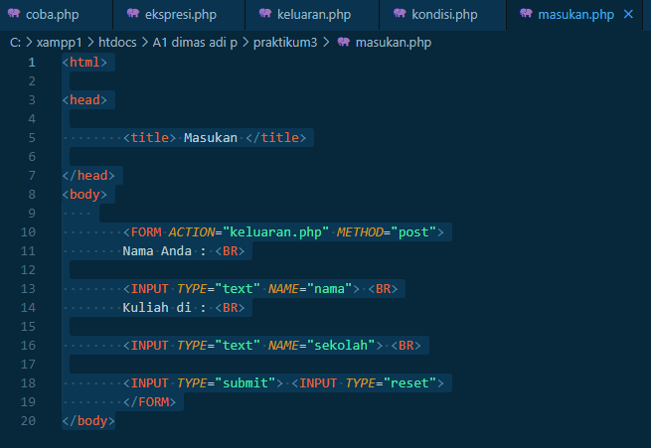

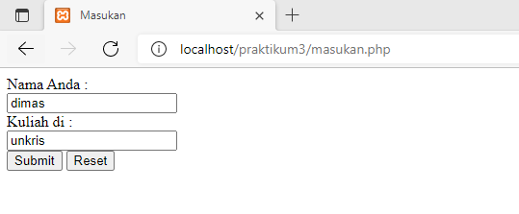

6. lok_glo.php

Script

| 1. <html> 2. <head> 3. <title> VARIABLE LOKAL DAN GLOBAL</title> 4. </head> 5. <body> 6. ***<?php*** 7. *Function* printklub ($NamaKlub) 8. { 9. Print ("Klub Sepak bola adalah $NamaKlub <BR> \n"); 10. } 11. *Function* MitraSby () 12. {*/* Variable Lokal */* 13. $NamaKlub**=**"Mitra Surabaya"; 14. printKlub($NamaKlub); 15. } 16. *Function* persija () 17. {*/* Variable Lokal */* 18. $NamaKlub**=**"Persija"; 19. printKlub($NamaKlub);} 20. *Function* Forever () 21. {*/* Variable Lokal */* 22. $NamaKlub**=**"AC milan"; 23. printKlub($NamaKlub); 24. } 25. */* Variable Global */* 26. $NamaKlub **=** "AC Milan"; 27. Forever(); 28. MitraSby(); 29. Persija(); 30. Forever(); 31. ***?>*** 32. </body> 33. </html> |
| --- |

Screenshot script dan hasil output

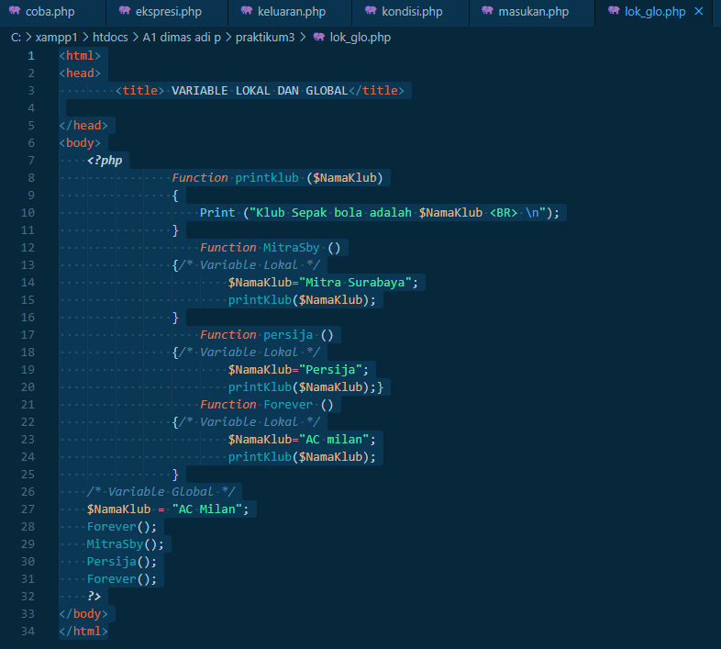

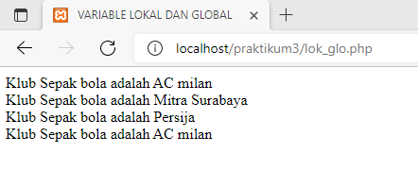

7. operator.php

Script

| 1. <html> 2. <head> 3. <title>Operator</title> 4. </head> 5. <body> 6. ***<?php*** 7. $Harga **=** 100; $Pengunjung **=** 8; 8. Print("Jumlah pengunjung hari ini $Pengunjung <BR> \n"); 9. Print("Total Pendapatan :"); Print ($Harga **\*** $Pengunjung); 10. ***?>*** 11. </body> 12. </html> |
| --- |

Screenshot script dan hasil output

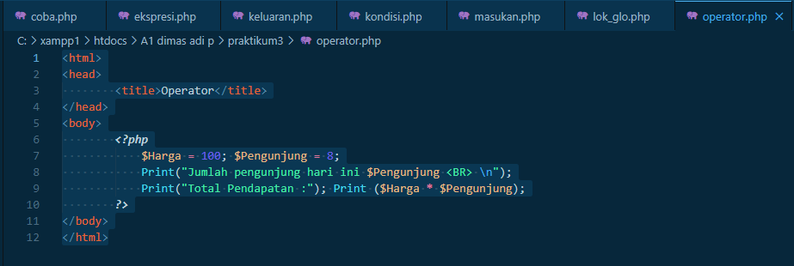

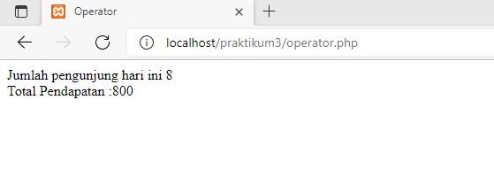

8. tanggal.php

Script

| 1. <html> 2. <head> 3. <title> Tanggal </title> </head> 4. <body> 5. Tanggal : 6. ***<?php*** 7. */* script untuk menuliskan tanggal */* 8. echo date ("d F Y"); 9. ***?>*** 10. </body> |
| --- |

Screenshot script dan hasil output

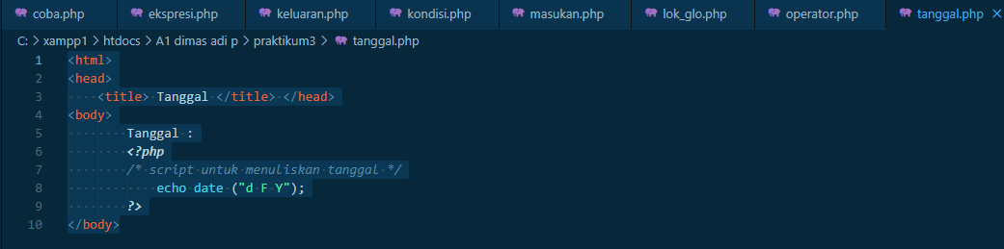

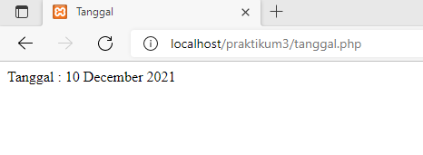

9. ulang.php

Script

| 1. ***<?php*** 2. $Tanggal**=**date ("d F Y"); 3. ***?>*** 4. <html> 5. <head> 6. <title> Pengulangan </title> 7. </head> 8. <body> 9. ***<?php*** 10. */*script pengenalan pengulangan */* 11. Print ("$Tanggal <BR> \n"); 12. For ($count**=**1; $count**<=**4; $count**++**) 13. { 14. echo ("Anda adalah calon webmaster <BR> \n"); 15. } 16. ***?>*** 17. </body> 18. </html> |
| --- |

Screenshot script dan hasil output

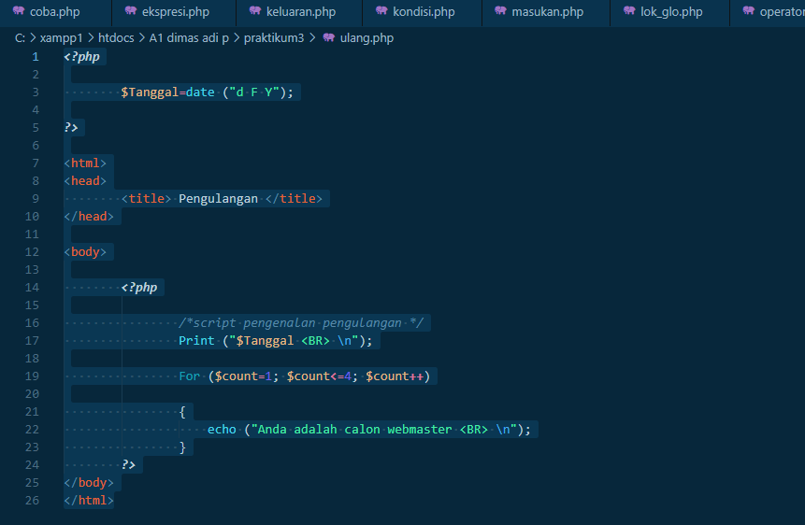

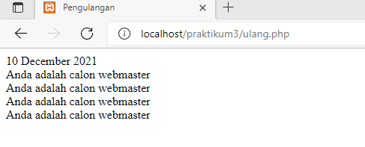

10. variable.php

Script

| 1. ***<?php*** 2. */* deklarasi variable */* 3. $Tanggal **=** date ("d m Y"); 4. $Nama **=** "praktikum"; 5. ***?>*** 6. <html> 7. <head> 8. <title> Variable </title> 9. </head> 10. <body> 11. ***<?php*** 12. */* script pengenalan variable */* 13. */* memanggil variable Tanggal */* 14. Print ("$Tanggal <BR> \n"); 15. */* memanggil variable Nama */* 16. Print ("$Nama, selamat datang didunia webmaster"); 17. ***?>*** 18. </body> |
| --- |

Screenshot script dan hasil output

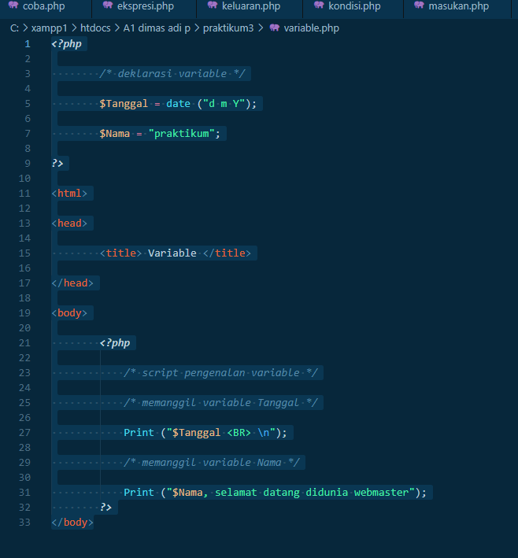

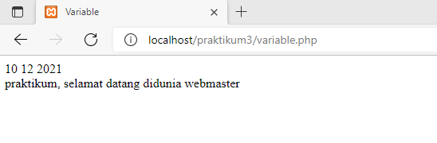

**Modul 4**

1. if.php

Script

| 1. <html> 2. <head> 3. <title> IF </title> 4. </head> 5. <body> 6. ***<?php*** 7. $X**=**100; 8. $Y**=**50; 9. **if** ($X **>** $Y) 10. { 11. Print ("X Lebih besar dari Y"); 12. } 13. ***?>*** 14. </body> 15. </html> |
| --- |

Screenshot script dan hasil output

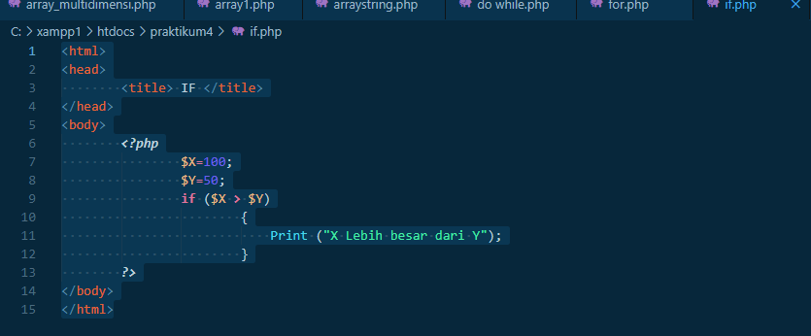

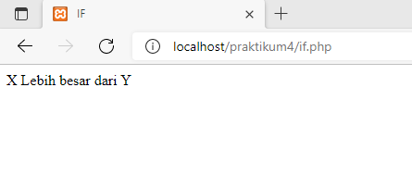

2. ifelse.php

Script

| 1. <html> 2. <head> 3. <title> IF </title> 4. </head> 5. <body> 6. ***<?php*** 7. $X**=**100; 8. $Y**=**50; 9. **if** ($X **>** $Y) 10. { 11. Print ("X Lebih besar dari Y"); 12. } 13. **else** 14. { 15. Print ("X Lebih kecil dari Y"); 16. } 17. ***?>*** 18. </body> 19. </html> |
| --- |

Screenshot script dan hasil output

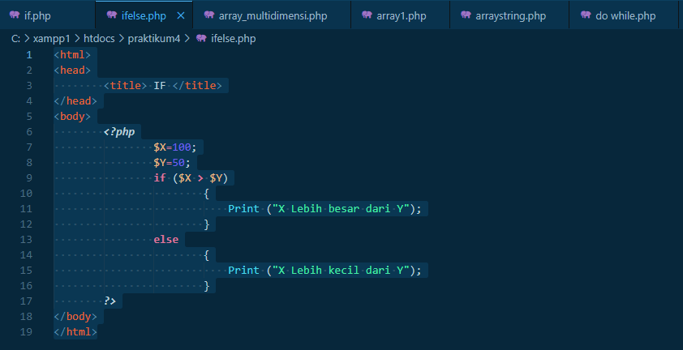

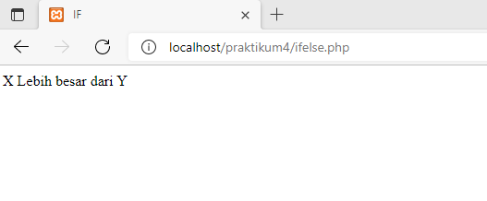

3. switch.php

Script

| 1. <html> 2. <head> 3. <title> SWITCH </title> 4. </head> 5. <body> 6. ***<?php*** 7. $indonesia_day**=**date("l"); 9. Switch($indonesia_day) 10. { **case** "Monday": 11. $indonesia_day **=** 12. "Senin"; 13. **break**; 15. **case** "Tuesday": 16. "Selasa"; 17. **break**; 18. **case** "Wednesday": 19. $indonesia_day **=** 20. "Rabu"; 21. **break**; 23. **case** "Thursday": 24. $indonesia_day **=** 25. "Kamis"; 26. **break**; 28. **case** "Friday": 29. $indonesia_day **=** 30. "Jumat"; 31. **break**; 33. **case** "Saturday": 34. $indonesia_day **=** 35. "Sabtu"; 36. **break**; 38. default: 39. $indonesia_day **=** 40. "Minggu"; 41. **break**; 42. } 44. print ("Hari ini adalah hari $indonesia_day") 45. ***?>*** 46. </body> 47. </html> |
| --- |

Screenshot script dan hasil output

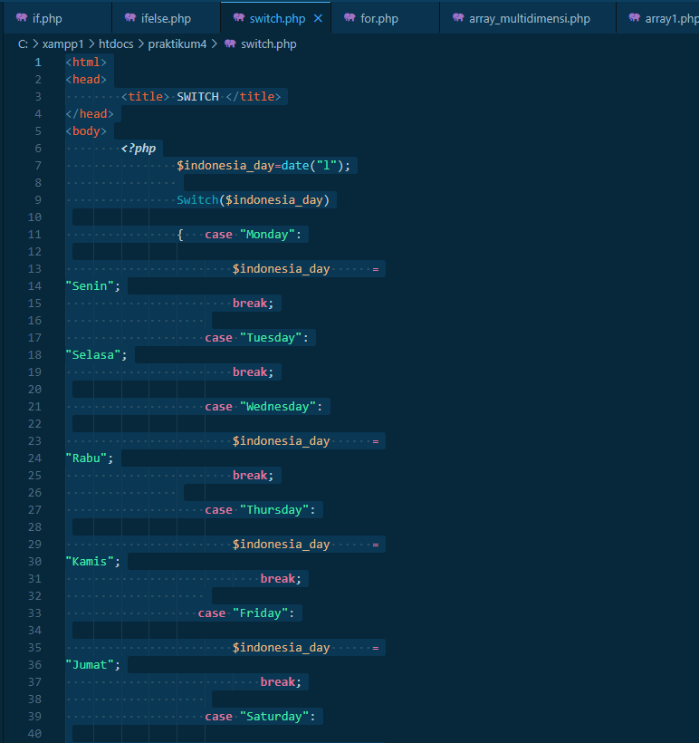

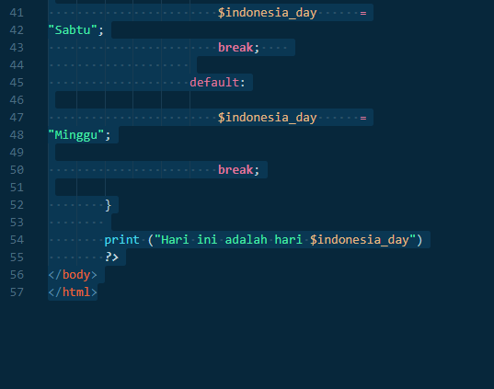

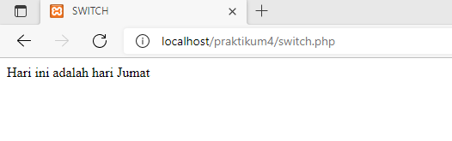

4. for.php

Script

| 1. <html> 2. <head><title>FOR</title> 3. <body> 4. ***<?php*** 5. **for** ($i**=**3; $i**<=**7; $i**++**) 6. { 7. print("<font size=$i>ERZA</font><br>"); 8. } 9. ***?>*** 10. </body> 11. </html> |
| --- |

Screenshot script dan hasil output

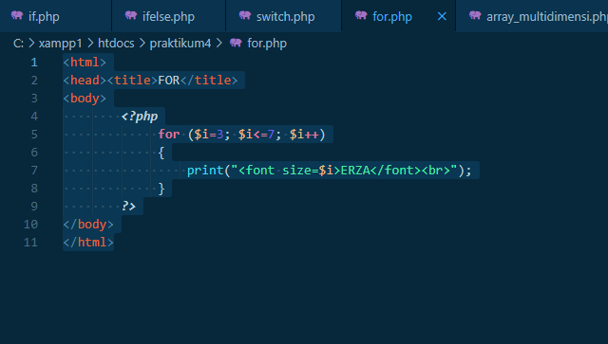

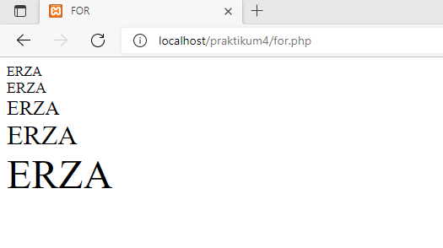

5. while.php

Script

| 1. <html> 2. <head> 3. <title>FOR</title> 4. <body> 5. ***<?php*** 6. $i**=**1; 7. **while**($i**<=**7) 8. { 9. print ("$i<br>"); 10. $i**++**; 11. } 12. ***?>*** 13. </body> 14. </html> |
| --- |

Screenshot script dan hasil output

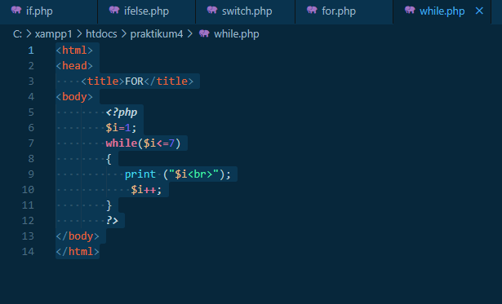

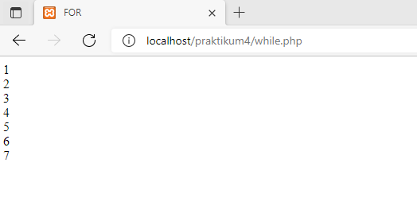

6. do while.php

Script

| 1. <html> 2. <head> 3. <title>FOR</title> 4. <body> 5. ***<?php*** 6. $i**=**1; 7. **do** 8. { 9. print ("$i<br>"); 10. $i**++**; 11. } 12. **while**($i**<=**7) 13. ***?>*** 14. </body> 15. </html> |
| --- |

Screenshot script dan hasil output

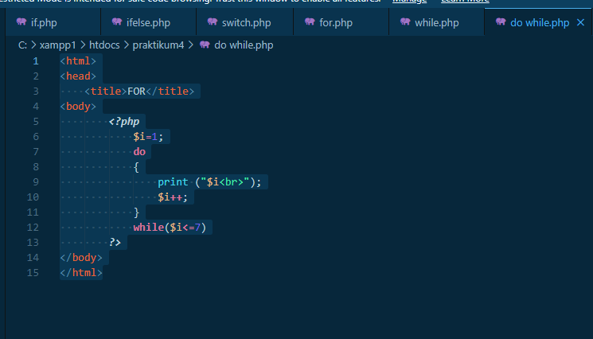

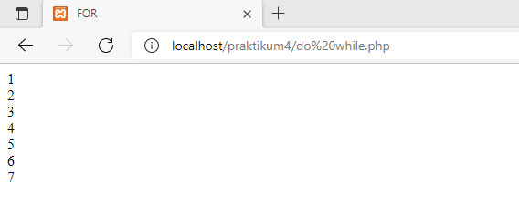

7. array1.php

Script

| 1. ***<?php*** 2. $nama_bulan**=**array("Januari","Februari","Maret","April","Mei","Juni", 3. "Juli","Agustus","September","Oktober","November","Desember"); 4. $bulan_ini**=**$nama_bulan[date("m")**-**1]; 5. echo "Sekarang Bulan <b>$bulan_ini</b>"; 6. ***?>*** |
| --- |

Screenshot script dan hasil output

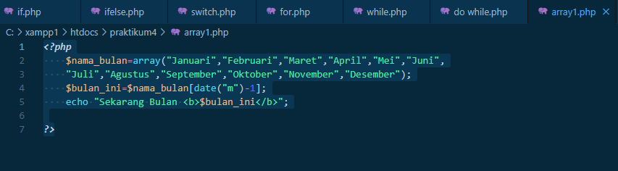

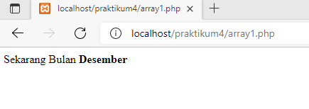

8. arraystring.php

Script

| 1. <html> 2. <head> 3. <title>Array Urut</title> 4. </head> 5. <body> 6. ***<?php*** 7. $teks1 **=** "Pemrograman Web dengan PHP"; 8. print("Teks Asli $teks1 : <br>"); 9. $hasil **=** explode ("",$teks1); 10. print ("<b>Setelah explode:</b><br>"); 11. print_r($hasil); 12. print("<br>"); 13. $gabung1 **=** implode("-",$hasil); 14. $gabung2 **=** join ("-",$hasil); 15. print("<b>Setelah implode:</b><br>"); 16. print_r($gabung1); 17. print("<br>"); 18. print("<b>Setelah implode:</b><br>"); 19. print_r($gabung2); 20. print("<br><br>"); 21. $teks2 **=** "17.7.2005"; 22. $apisah1 **=** preg_split('[/.-]',$teks2); 23. print("Teks Asli: $teks2 <br>"); 24. print_r($apisah1); 25. print("<br><br>"); 26. $teks3 **=** "PEMROGRAMAN PHP"; 27. $apisah2 **=** preg_split('//',$teks3,**-**1,PREG_SPLIT_NO_EMPTY); 28. $banyak **=** sizeof($apisah2); 29. print("Teks Asli: $teks3 <br>"); 30. print("<b>Setelah preg_split:</b><br>"); 31. $i**=**0; 32. **while**($i**<**$banyak) 33. { 34. print($apisah2[$i]**.**" "); 35. $i**++**; 36. } 37. ***?>*** 38. </body> 39. </html> |
| --- |

Screenshot script dan hasil output

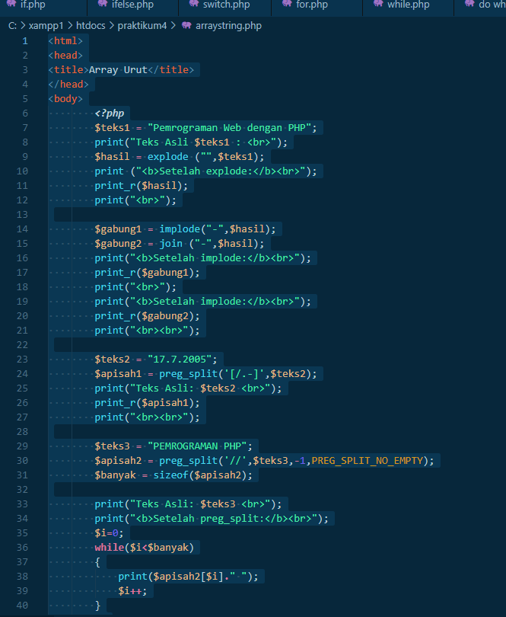

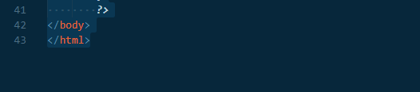

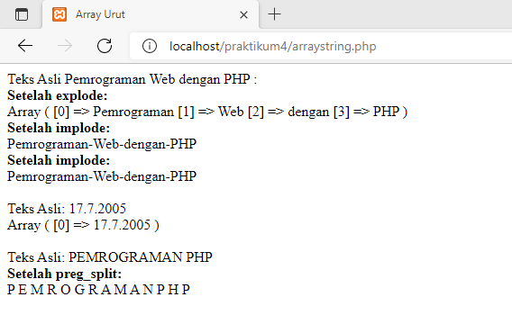

9. arraymultidimensi.php

Script

| 1. ***<?php*** 2. $data**=@**array( 3. array(judul **=>** "Keamanan Jaringan Internet",Pengarang **=>** "Onno W 4. Purbo",), 5. array(judul **=>** "Pengenalan SQL",Pengarang **=>** "Sri Wahyuni",), 6. array(judul **=>** "Network Security",Pengarang **=>** "Tom Thomas",), 7. ); 8. echo"Array Multidimensi<br><br>"; 9. **foreach**($data **as** $val) 10. { 11. **foreach**($val **as** $key **=>** $data2) 12. { 13. echo "$key : $data2 <br>"; 14. } 15. echo "<br>"; 16. } |
| --- |

Screenshot script dan hasil output

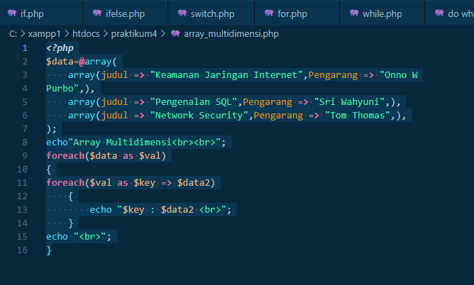

**TUGAS 2**

1. Halaman depan

index.html

Script

| <!DOCTYPE html>  <html>  <head>  <title> Praktikum Pemrograman Web </title>  <link rel="stylesheet" type="text/css" href="style.css">  </head>  <body>  <div class="contents">  <h1> PRAKTIKUM PEMROGRAMAN WEB </h1>  <h2> Nama : Dimas Adi Prasetyo </h2>  <h2> NIM : 2070231004 </h2>  <h2> Kelas: IT A1</h2>  </div>  <br><br><br><br><br><br>  <div class="button">  <a href="home.html" class="btn"><img src="123.png"></a>  </div>  </body>  </html> |
| --- |

style.css

Script

| h1 { font-size:50pt;  font-style: bold;  color: white;  text-align: center;  }  h2{text-align: center;  font-size:35pt;  font-style: bold;  color: white;  }  body {  background-image: url(0000.jpg);  background-size: cover;  background-position: center;  background-attachment: fixed;  height: 100vh;  }  .button {  position: absolute;  top: 50%;  left: 35%;  } |
| --- |

Screenshot script dan hasil output

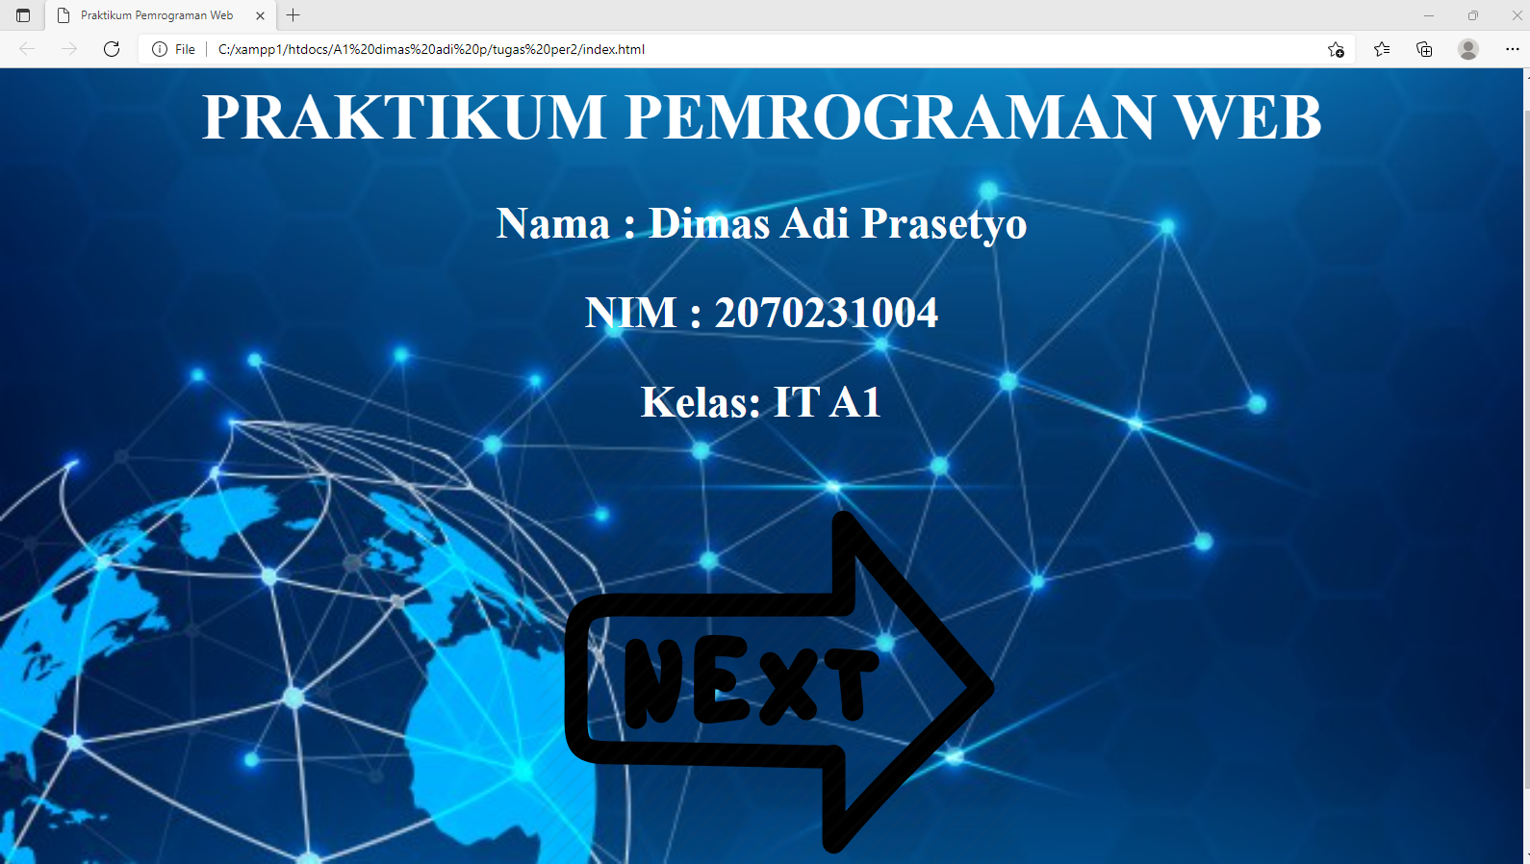

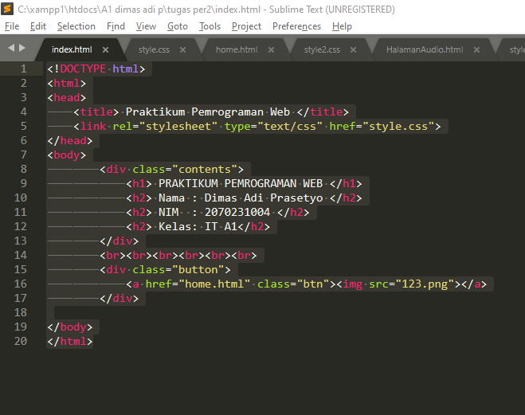

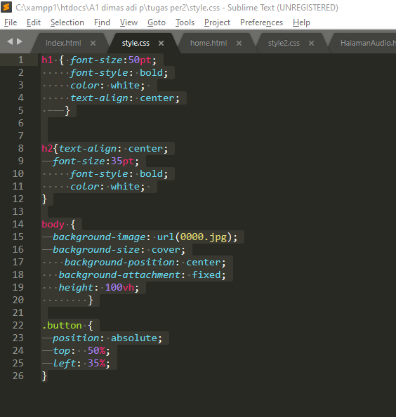

1. Home

home.html

Script

| <!DOCTYPE html>  <html>  <head>  <title> HOME </title>  <link rel="stylesheet" type="text/css" href="style2.css">  </head>  <body>  <div class="contents">  <h1> SELAMAT DATANG DIMENU TUGAS AKHIR PRAKTIKUM SAYA </h1>  </div>  <div class="back">  <a href="index.html"><img src="back.png" width="200px" height="250px"></a>  </div>  <div class="musik">  <a href="HalamanAudio.html"><img src="musik.jpg" width="380px" height="200px"></a>  </div>  <div class="tabel">  <a href="Tabel.html"><img src="tabel.jpg" width="200px" height="200px"></a>  </div>  <div class="kalender">  <a href="kalender.html"><img src="kalender.jpg" width="200px" height="200px"></a>  </div>  <div class="bank">  <a href="bank.html"><img src="bank.png" width="200px" height="200px"></a>  </div>  <div class="univ">  <a href="kampus.html"><img src="kampus.jpg" width="200px" height="200px"></a>  </div>  <div class="bio">  <a href="biodata.html"><img src="biodata.png" width="300px" height="400px"></a>  </div>  <div class="medsos">  <a href="medsos.html"><img src="medsos.png" width="300px" height="398px"></a>  </div>  </body>  </html> |
| --- |

style2.css

Script

| h1 { font-size: 35pt;  font-style: bold;  color: blue;  text-align: center;  }  body {  background-image: url(backgroundh1.jpg);  background-size: cover;  background-position: center;  background-attachment: fixed;  height: 100vh;  }  .back {  position: absolute;  top: 35%;  left: 5%;  }  .musik {  position: absolute;  top: 25%;  left: 20%;  }  .tabel {  position: absolute;  top: 49%;  left: 20%;  }  .kalender {  position: absolute;  top: 49%;  left: 32%;  }  .bank {  position: absolute;  top: 25%;  left: 44%;  }  .univ {  position: absolute;  top: 49%;  left: 44%;  }  .medsos {  position: absolute;  top: 25%;  left: 56.6%;  }  .bio {  position: absolute;  top: 25%;  left: 76%;  } |
| --- |

Screenshot script dan hasil output



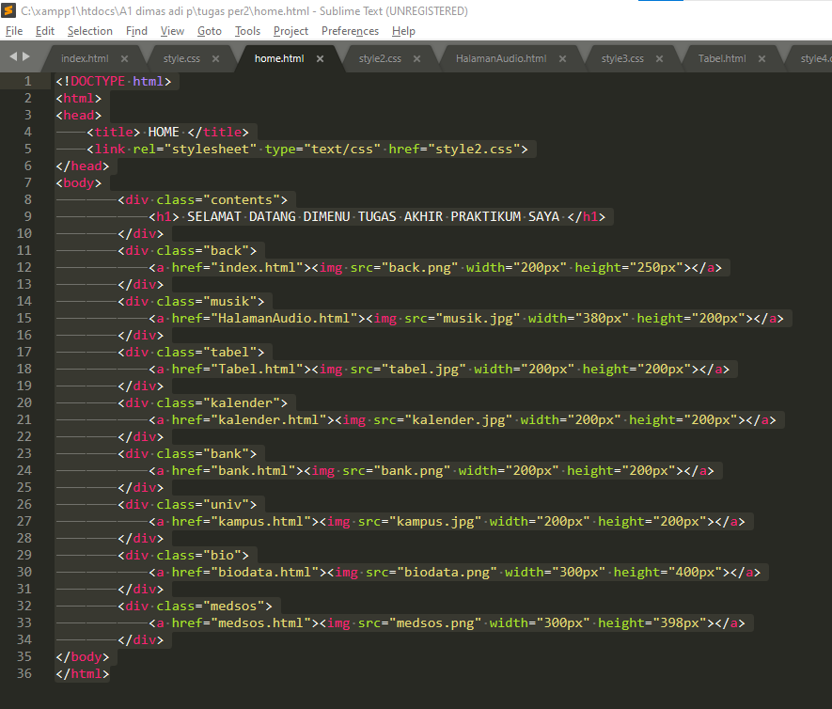

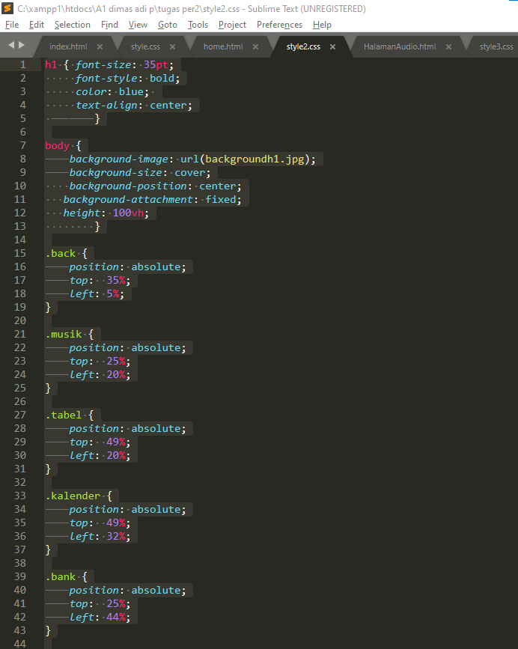

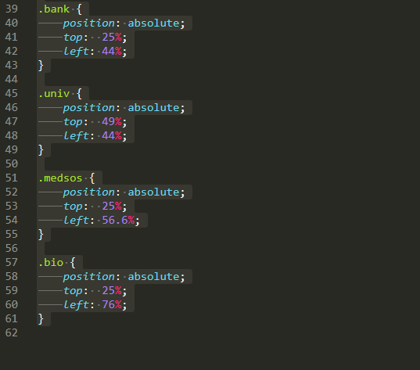

1. Halaman Audio

Halamanaudio.html

Script

| <!DOCTYPE html>  <html>  <head>  <title> AUDIO </title>  <link rel="stylesheet" type="text/css" href="style3.css">  </head>  <body>  <div class="contents">  <h1> SELAMAT DATANG DIHALAMAN AUDIO SAYA </h1>  </div>  <div class="lagu">  <h2> 24kGoldn - Mood ft. Iann Dior </h2>  <audio controls>  <source src="24kGoldn - Mood (Lyrics) ft. Iann Dior.mp3" type="audio/mpeg">  </audio>  <h2> GAYLE-abcdefu </h2>  <audio controls>  <source src="GAYLE-abcdefu.mp3" type="audio/mpeg">  </audio>  <h2> Glass-Animals-Heat-Waves </h2>  <audio controls>  <source src="Glass-Animals-Heat-Waves.mp3" type="audio/mpeg">  </audio>  </div>  <div class="musik">  <img src="audio.gif" width="1100px" height="400px"></a>  </div>  <div class="back">  <a href="home.html"><img src="back2.png" width="300px" height="200px"></a>  </div>  </body>  </html> |
| --- |

style3.css

Script

| h1 { font-size: 35pt;  font-style: bold;  color: blue;  text-align: center;  }  h2 {font-size: 18pt;  font-style: italic;  color: white;  }  body {background-color: black;  background-size: cover;  background-position: center;  background-attachment: fixed;  height: 100vh;  }  .lagu {  position: absolute;  top: 20%;  left: 5%;  }  .musik {  position: absolute;  top: 47%;  left: 30%;  }  .back {  position: absolute;  top: 70%;  left: 5%;  } |
| --- |

Screenshot script dan hasil output

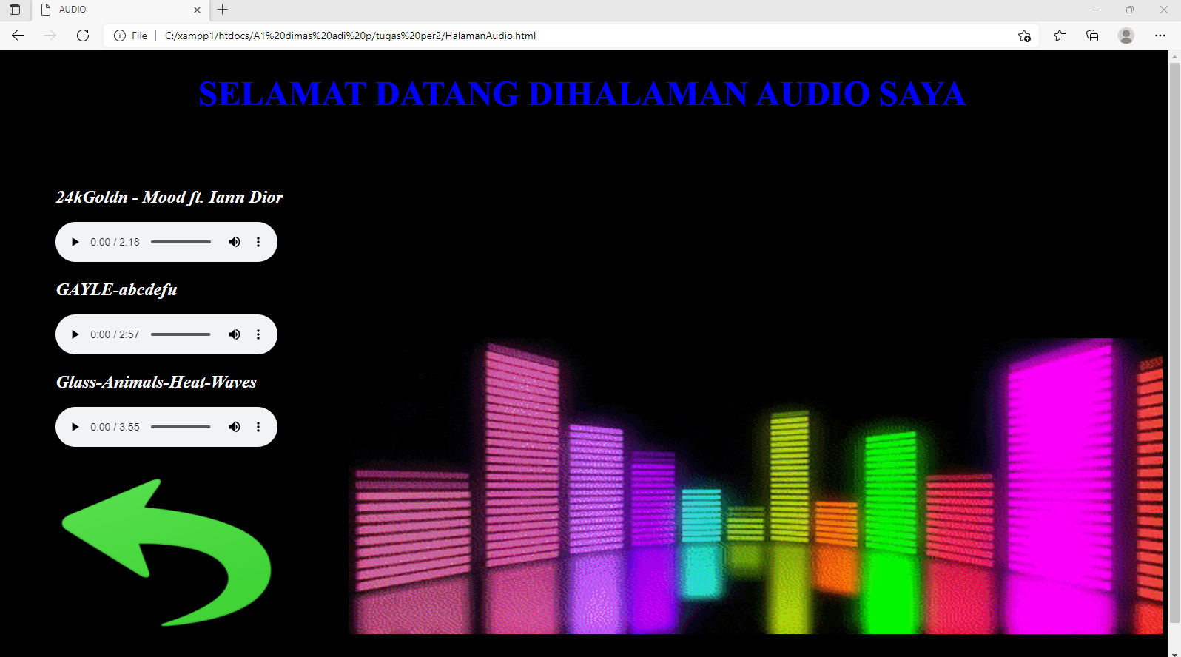

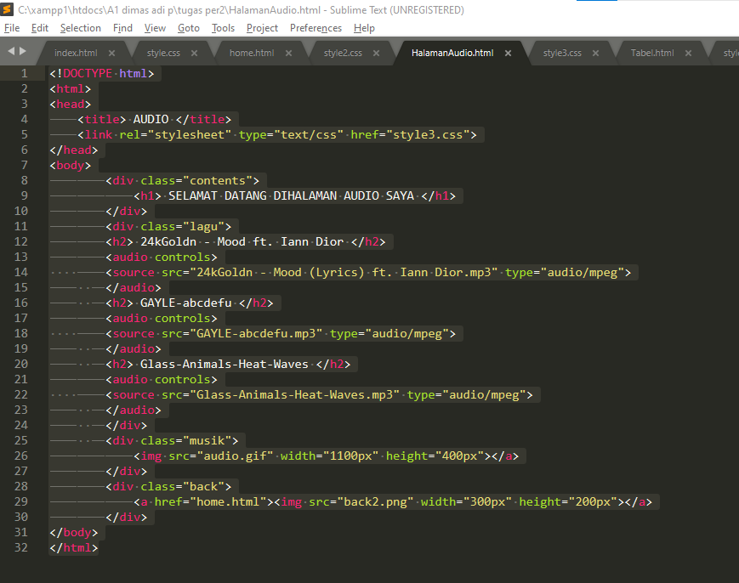

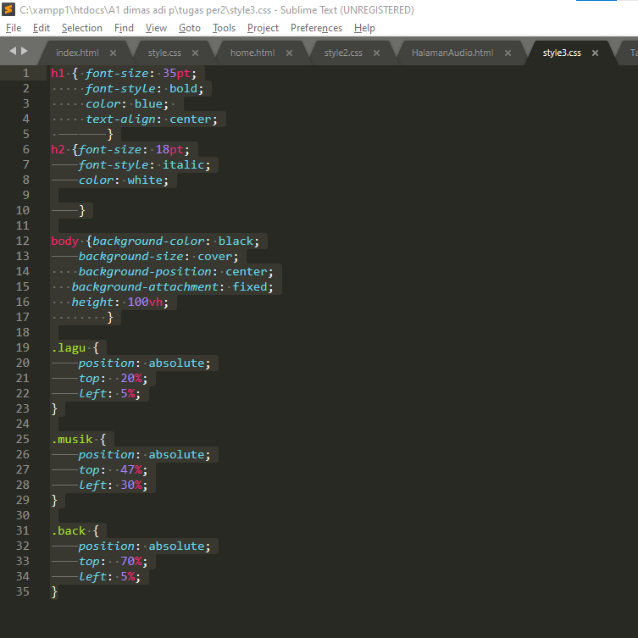

1. Halaman Jadwal/Tabel

tabel.html

Script

| <!DOCTYPE html>  <html>  <head>  <title> Tabel </title>  <link rel="stylesheet" type="text/css" href="style4.css">  </head>  <body>  <h1> TABEL JADWAL KULIAH </h1>  <h1> SEMESTER GANJIL TAHUN AKADEMIK 2019-2020 </h1>  <h1> PROGRAM STUDI TEKNIK INFORMATIKA A1 </h1>  <div class="button">  <a href="home.html" class="btn"><img src="back.png" width="150px" height="150px"> </a>  </div>  <div class="tbl">  <table border="2" cellpadding="10">  <tr bgcolor="yellow">  <td>NO</td>  <td>MATA KULIAH</td>  <td>NAMA DOSEN</td>  <td>HARI</td>  <td>JAM</td>  <td>RUANGAN</td>  </tr>  <tr bgcolor="red">  <td>1</td>  <td>Grafika Komputer</td>  <td>Suliatianto, MM, MKom</td>  <td>SENIN</td>  <td>08.00 - 10.30</td>  <td>ONLINE</td>  </tr>  <tr bgcolor="blue water">  <td>2</td>  <td>Pemrograman Web</td>  <td>Avip Kurniawan, ST, MKom</td>  <td>SENIN</td>  <td>13.00 - 15.30</td>  <td>ONLINE</td>  </tr>  <tr bgcolor="orange">  <td>3</td>  <td>Pendidikan Bhs. Inggris 2</td>  <td>Drs. Anwar Sihombing, MPd</td>  <td>SELASA</td>  <td>08.00 - 09.30</td>  <td>ONLINE</td>  </tr>  <tr bgcolor="green">  <td>4</td>  <td>Basis Data Lanjutan</td>  <td>Ali Khumaidi, MKom</td>  <td>SELASA</td>  <td>10.00 - 12.30</td>  <td>ONLINE</td>  </tr>  <tr bgcolor="pink">  <td>5</td>  <td>Manajemen & Keamanan Jaringan</td>  <td>Nur Hikmah, ST, MKom</td>  <td>SELASA</td>  <td>13.30 - 16.00</td>  <td>ONLINE</td>  </tr>  <tr bgcolor="blue">  <td>6</td>  <td>Teori Graf dan Otomata</td>  <td>Agustina Indarwati, SSi, MSi</td>  <td>RABU </td>  <td>08.00 - 10.30</td>  <td>ONLINE</td>  </tr>  <tr bgcolor="abu-abu">  <td>7</td>  <td>Komputasi Cerdas</td>  <td>Ali Khumaidi, MKom</td>  <td>KAMIS</td>  <td>08.00 - 10.30</td>  <td>ONLINE</td>  </tr>  <tr bgcolor="coklat">  <td>8</td>  <td>Statistika dan Probabilitas</td>  <td>Tri Hartati, SKom, MKom</td>  <td>KAMIS</td>  <td>11.00 - 13.30</td>  <td>ONLINE</td>  </tr>  </table>    </div>  </body>  </html> |
| --- |

style4.css

Script

| h1 { font-size:25pt;  font-style: bold;  color: black;  text-align: center;  top: 1%;  }  body {  background-image: url(jadwal.jpg);  background-size: cover;  background-position: center;  background-attachment: fixed;  height: 100vh;  }  .button {  position: absolute;  top: 80%;  left: 45%;  }  .tbl {position: absolute;  top: 28%;  left: 25%;  border: 6px solid black;  } |
| --- |

Screenshot script dan hasil output

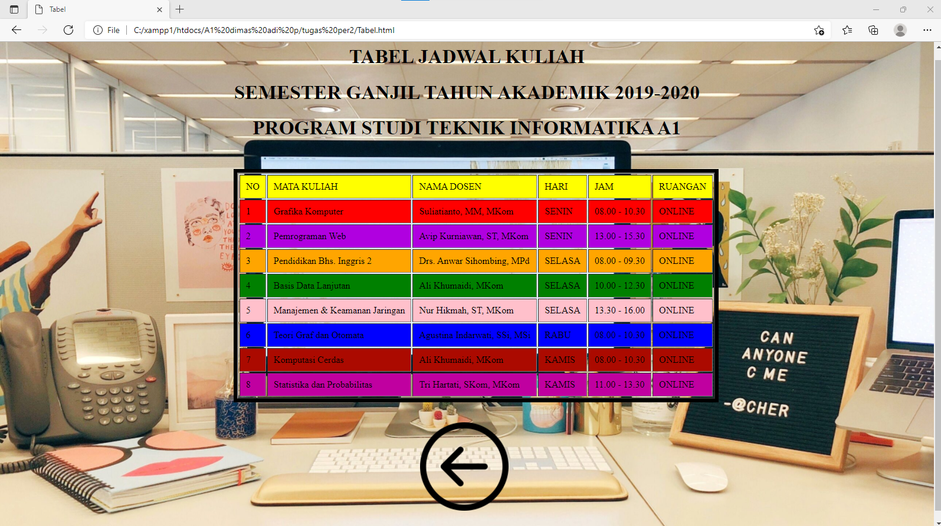

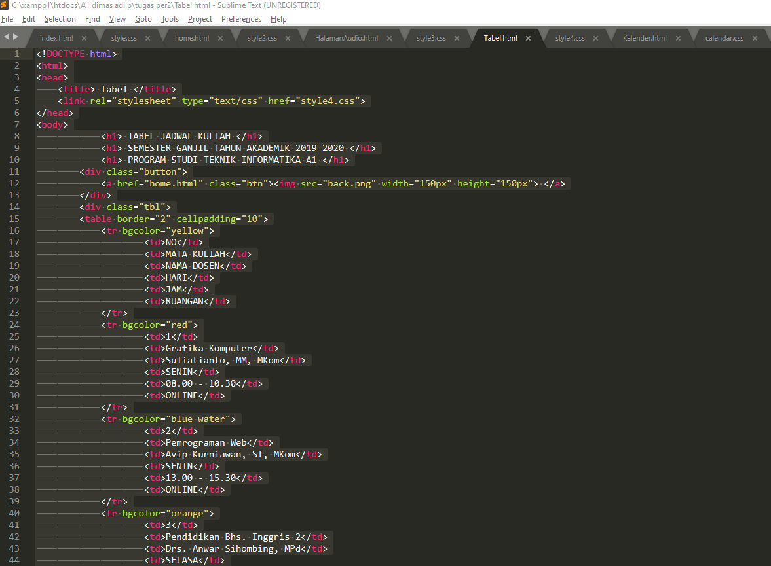

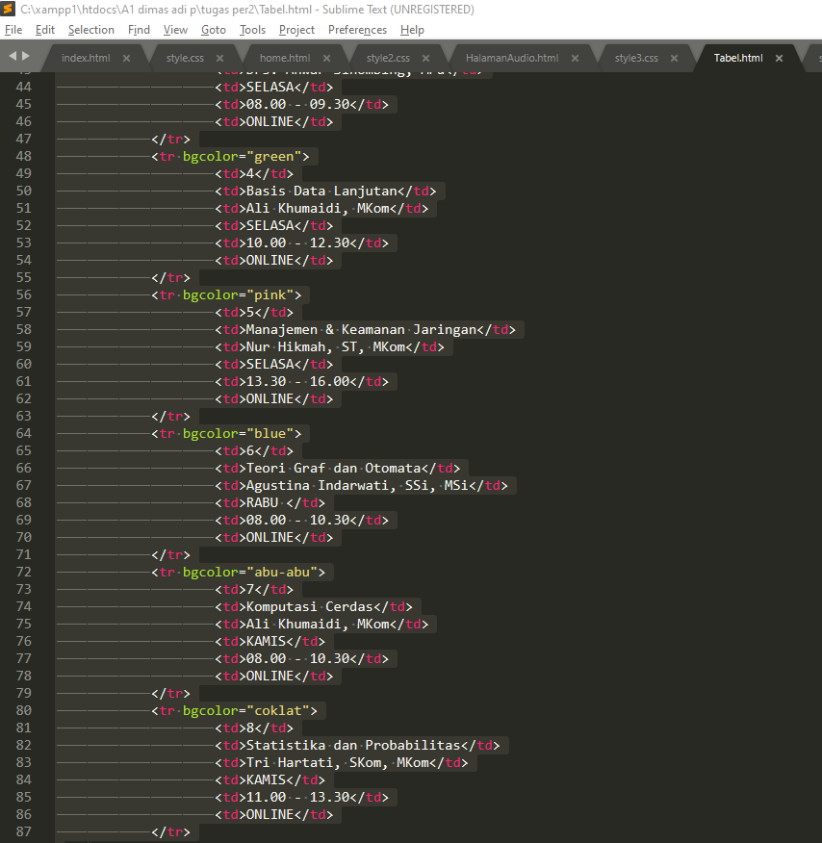

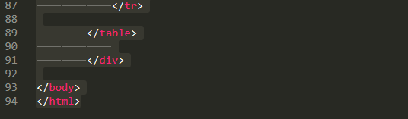

1. Halaman Kalender

Kalender.html

Script

| <!DOCTYPE>  <html>  <head>  <link rel="stylesheet" type="text/css" href="calendar.css">  </head>  <body>  <h1> SELAMAT DATANG DI HALAMAN KALENDER SAYA </h1>  <div class="button">  <a href="home.html" class="btn"><img src="back.png" width="150px" height="150px"> </a>  </div>  <div class="wrapper">  <div class="container-calendar">  <h3 id="monthAndYear"></h3>  <div class="button-container-calendar">  <button id="previous" onclick="previous()">&#8249;</button>  <button id="next" onclick="next()">&#8250;</button>  </div>    <table class="table-calendar" id="calendar" data-lang="en">  <thead id="thead-month"></thead>  <tbody id="calendar-body"></tbody>  </table>    <div class="footer-container-calendar">  <label for="month">Jump To: </label>  <select id="month" onchange="jump()">  <option value=0>Jan</option>  <option value=1>Feb</option>  <option value=2>Mar</option>  <option value=3>Apr</option>  <option value=4>May</option>  <option value=5>Jun</option>  <option value=6>Jul</option>  <option value=7>Aug</option>  <option value=8>Sep</option>  <option value=9>Oct</option>  <option value=10>Nov</option>  <option value=11>Dec</option>  </select>  <select id="year" onchange="jump()"></select>  </div>  </div>  </div>  <script src="calendar.js" type="text/javascript"></script>  </body>  </html> |
| --- |

calendar.css

Script

| html {  font-family: sans-serif;  font-size: 15px;  line-height: 1.4;  color: #444;  }  h1 { font-size:30pt;  font-style: bold;  color: white;  text-align: center;  top: 1%;  }  body {  background-image: url(kal.jpg);  background-size: cover;  background-position: center;  background-attachment: fixed;  height: 100vh;  }  .button {  position: absolute;  top: 80%;  left: 45%;  }  .wrapper {  margin: 15px auto;  max-width: 1100px;  }  .container-calendar {  background: #ffffff;  padding: 15px;  width: 1000px;  height: 400px;  margin: 0 auto;  overflow: auto;  }  .button-container-calendar button {  cursor: pointer;  display: inline-block;  zoom: 1;  background: gray;  color: #fff;  border: 1px solid #0aa2b5;  border-radius: 4px;  padding: 5px 10px;  }  .table-calendar {  border-collapse: collapse;  width: 100%;  }  .table-calendar td, .table-calendar th {  padding: 5px;  border: 3px solid black;  text-align: center;  vertical-align: top;  }  .date-picker.selected {  font-weight: bold;  outline: 1px dashed #00BCD4;  }  .date-picker.selected span {  border-bottom: 2px solid currentColor;  }  /* sunday */  .date-picker:nth-child(1) {  color: red;  }  /* friday */  .date-picker:nth-child(6) {  color: green;  }  #monthAndYear {  text-align: center;  margin-top: 0;  }  .button-container-calendar {  position: relative;  margin-bottom: 1em;  overflow: hidden;  clear: both;  }  #previous {  float: left;  }  #next {  float: right;  }  .footer-container-calendar {  margin-top: 1em;  border-top: 1px solid #dadada;  padding: 10px 0;  }  .footer-container-calendar select {  cursor: pointer;  display: inline-block;  zoom: 1;  background: #ffffff;  color: #585858;  border: 1px solid #bfc5c5;  border-radius: 3px;  padding: 5px 1em;  } |
| --- |

Screenshot script dan hasil output

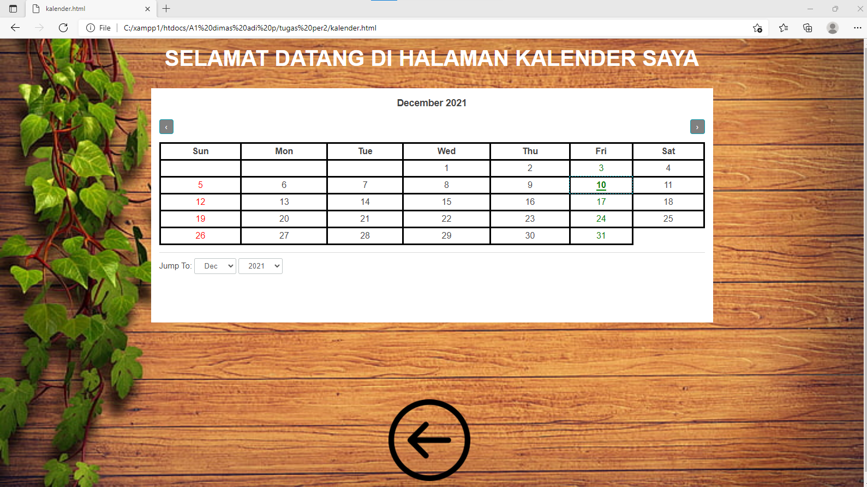

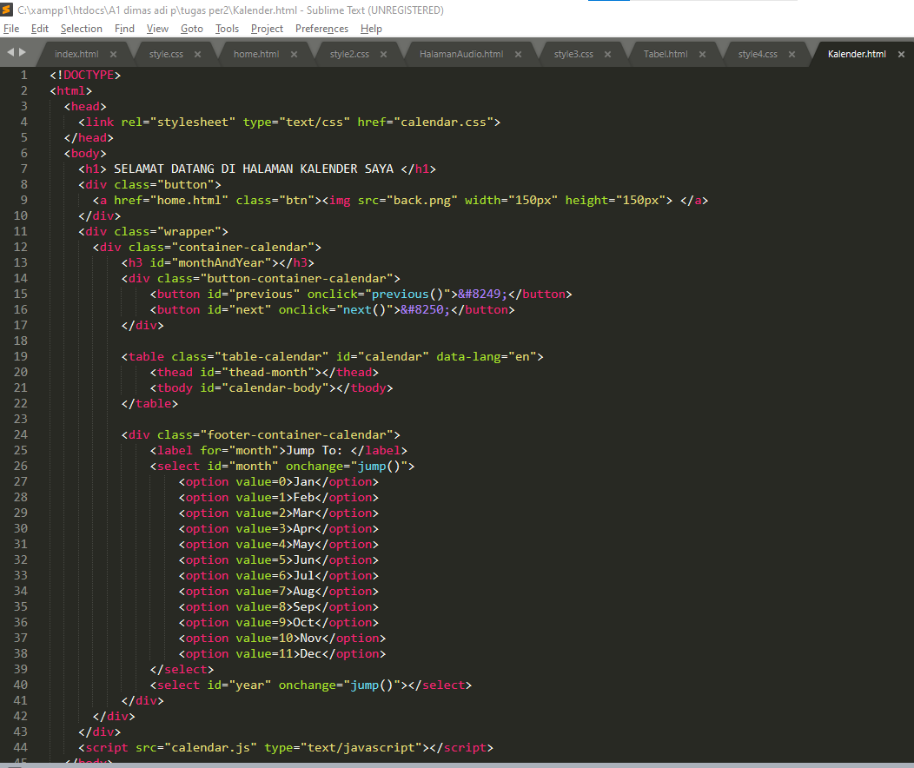

1. Halaman Bank

bank.html

Script

| <!DOCTYPE html>  <html>  <head>  <title> Bank </title>  <link rel="stylesheet" type="text/css" href="style5.css">  </head>  <body>  <div class="contents">  <h1> SELAMAT DATANG DIHALAMAN BANK SAYA </h1>  </div>  <div class="back">  <a href="home.html"><img src="back.png" width="200px" height="250px"></a>  </div>  <div class="mandiri">  <a href="https://bankmandiri.co.id/"><img src="mandiri.jpg" width="500px" height="200px"></a>  </div>  <div class="BNI">  <a href="https://www.bni.co.id/id-id/"><img src="BNI.png" width="500px" height="200px"></a>  </div>  <div class="BCA">  <a href="https://www.bca.co.id/id/individu"><img src="BCA.png" width="500px" height="200px"></a>  </div>  </body>  </html> |
| --- |

style5.css

Script

| h1 { font-size:25pt;  font-style: bold;  color: black;  text-align: center;  top: 1%;  }  body {  background-image: url(atm.jpg);  background-size: cover;  background-position: center;  background-attachment: fixed;  height: 100vh;  }  .back {  position: absolute;  top: 38%;  left: 80%;  }  .BNI {  position: absolute;  top: 15%;  left: 30%;  }  .mandiri {  position: absolute;  top: 40%;  left: 30%;  }  .BCA {  position: absolute;  top: 65%;  left: 30%;  } |
| --- |

Screenshot script dan hasil output

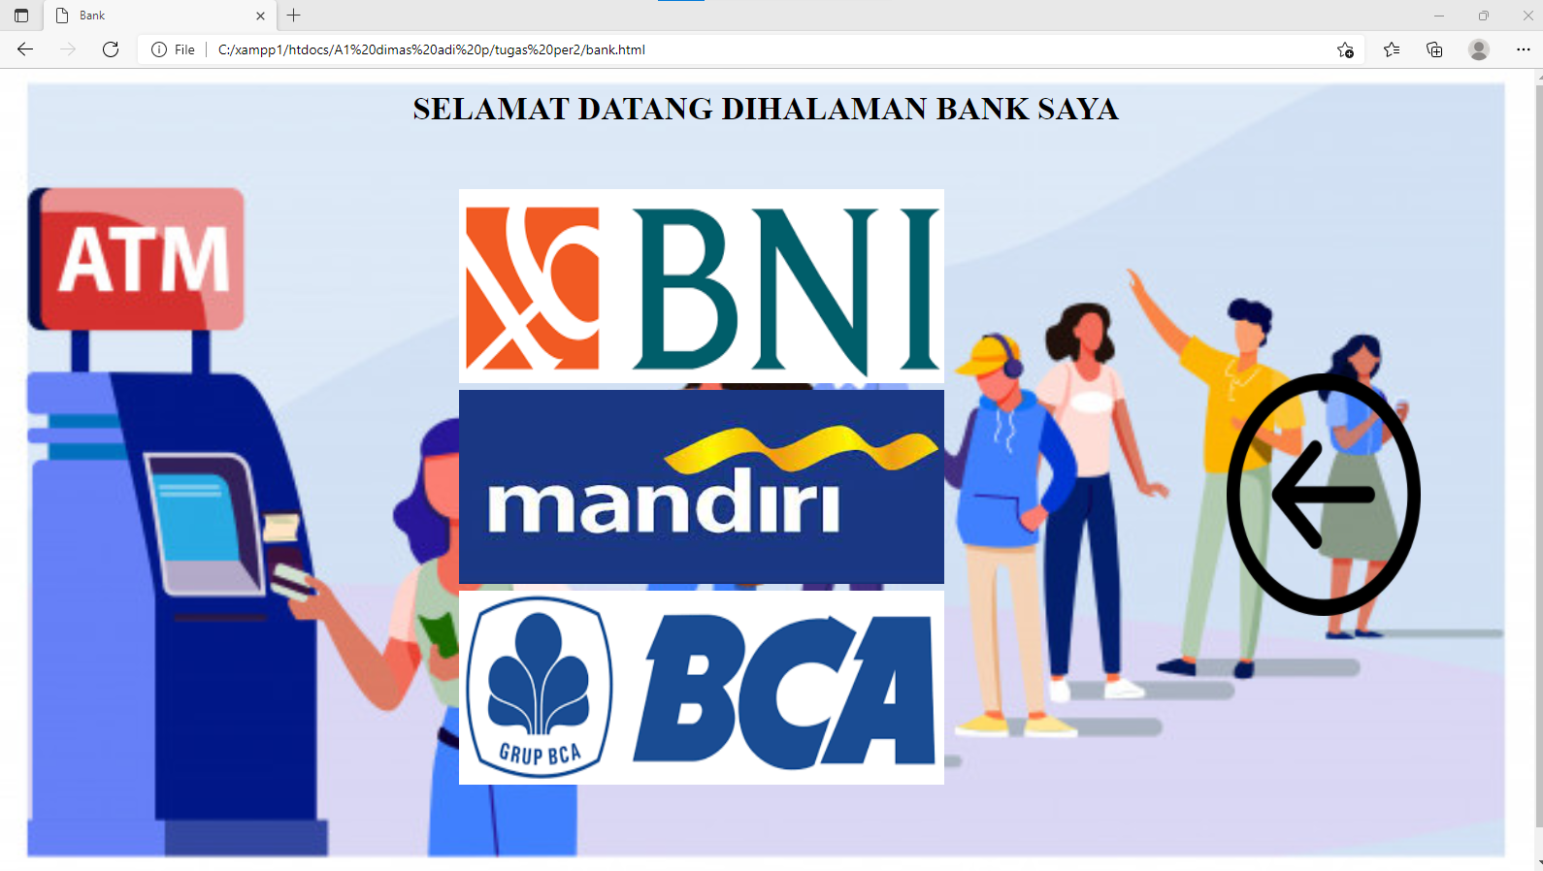

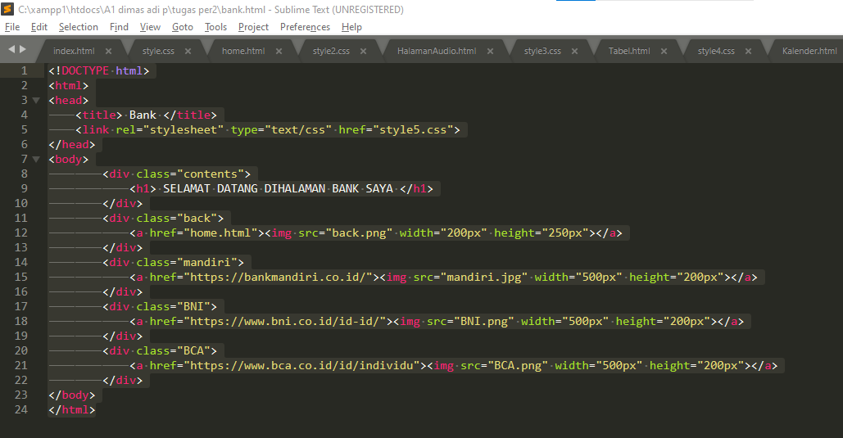

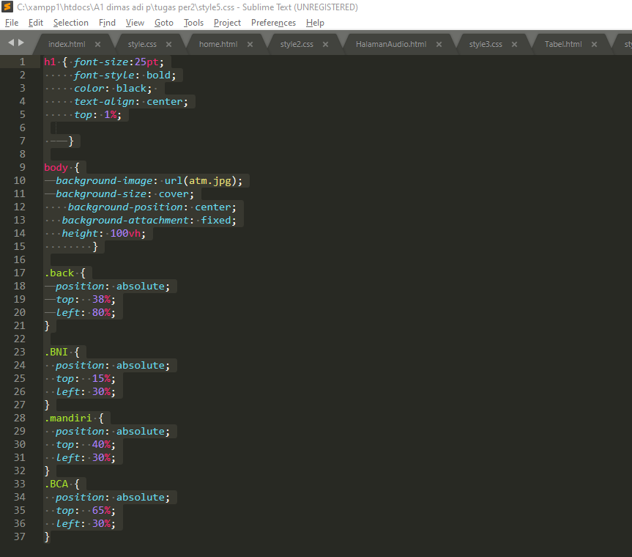

1. Halaman Kampus/Univ

kampus.html

Script

| <!DOCTYPE html>  <html>  <head>  <title> UNIVERSITAS </title>  <link rel="stylesheet" type="text/css" href="style6.css">  </head>  <body>  <div class="contents">  <h1> SELAMAT DATANG DIHALAMAN UNIVERSITAS SAYA </h1>  </div>  <div class="back">  <a href="home.html"><img src="back.png" width="100px" height="100px"></a>  </div>  <div class="unkris">  <a href="https://unkris.ac.id/"><img src="unkris.png" width="300px" height="250px"></a>  </div>  <div class="ITB">  <a href="https://www.itb.ac.id/"><img src="itb.png" width="300px" height="250px"></a>  </div>  <div class="UNPAD">  <a href="https://www.unpad.ac.id/"><img src="unpad.png" width="300px" height="250px"></a>  </div>  </body>  </html> |
| --- |

style6.css

Script

| h1 { font-size:25pt;  font-style: bold;  color: blue;  text-align: center;  top: 1%;  }  body {  background-image: url(perpus.jpg);  background-size: cover;  background-position: center;  background-attachment: fixed;  height: 100vh;  }  .back {  position: absolute;  top: 80%;  left: 46%;  }  .unkris {  position: absolute;  top: 40%;  left: 40%;  }  .ITB {  position: absolute;  top: 40%;  left: 20%;  }  .UNPAD {  position: absolute;  top: 40%;  left: 60%;  } |
| --- |

Screenshot script dan hasil output

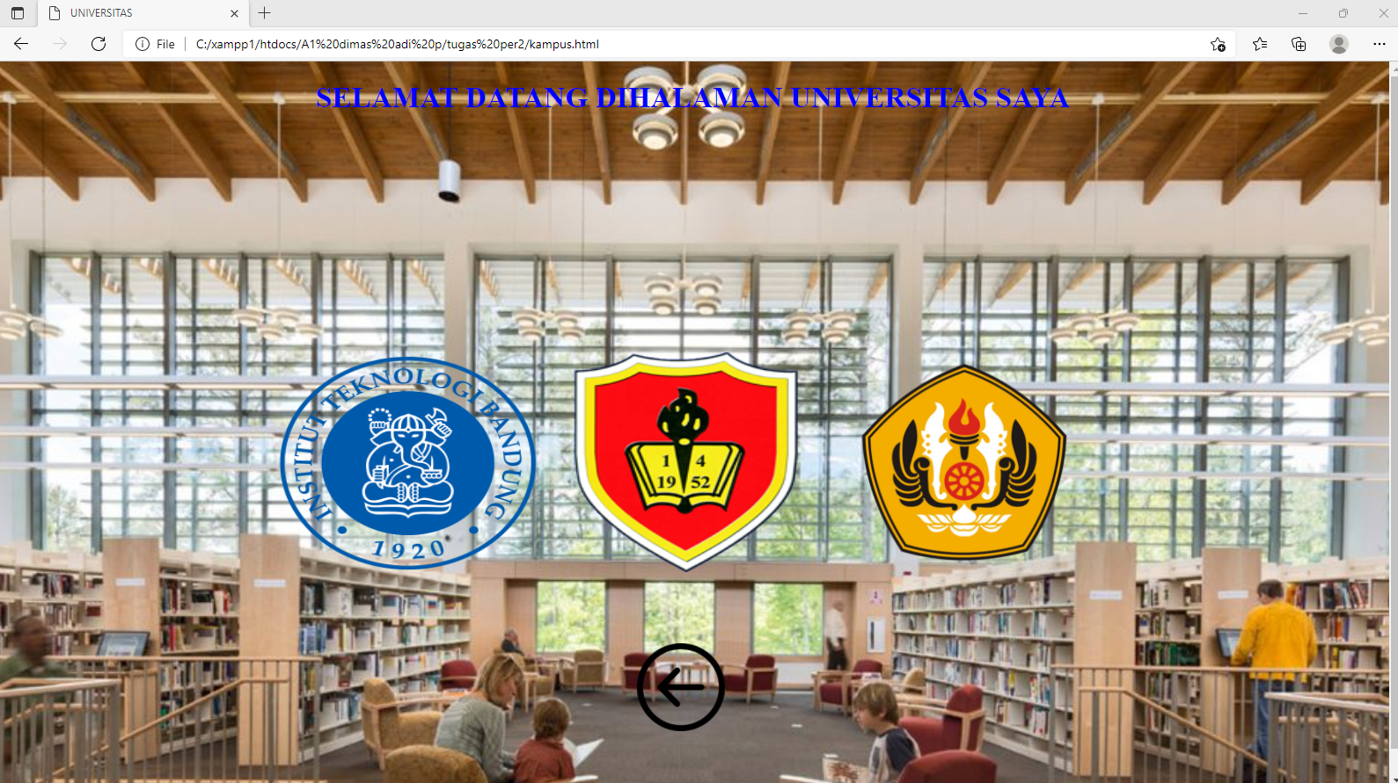

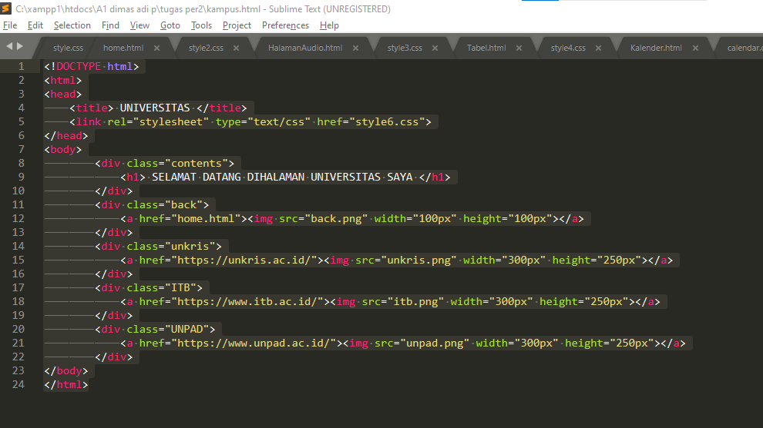

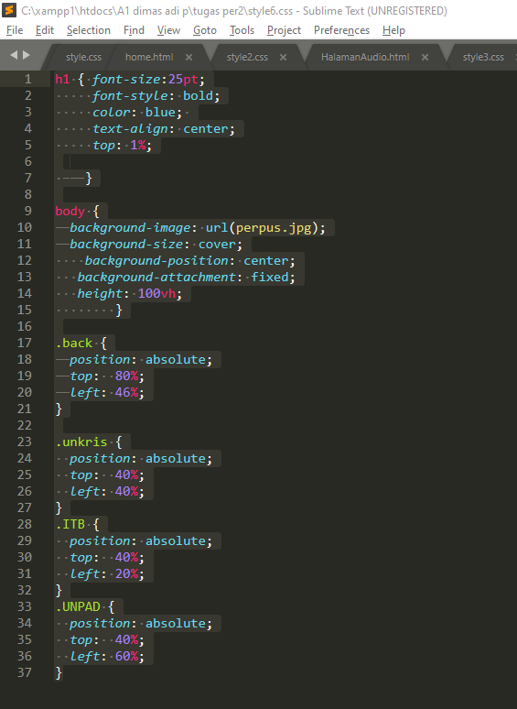

1. Halaman Media Sosial

medsos.html

Script

| <!DOCTYPE html>  <html>  <head>  <title> MEDIA SOSIAL </title>  <link rel="stylesheet" type="text/css" href="style7.css">  </head>  <body>  <div class="contents">  <h1> SELAMAT DATANG DIHALAMAN MEDIA SOSIAL SAYA </h1>  </div>  <div class="back">  <a href="home.html"><img src="back.png" width="100px" height="100px"></a>  </div>  <div class="facebook">  <a href="https://www.facebook.com/dimas.adiprasetyo.10"><img src="fb.png" width="250px" height="250px"></a>  </div>  <div class="instagram">  <a href="https://www.instagram.com/dipp017/"><img src="ig.png" width="300px" height="250px"></a>  </div>  <div class="twitter">  <a href="https://twitter.com/dadipp799"><img src="twitter.png" width="250px" height="250px"></a>  </div>  </body>  </html> |
| --- |

style7.css

Script

| h1 { font-size:25pt;  font-style: bold;  color: black;  text-align: center;  top: 1%;  }  body {  background-image: url(perpus.jpg);  background-size: cover;  background-position: center;  background-attachment: fixed;  height: 100vh;  }  .back {  position: absolute;  top: 80%;  left: 45%;  }  .facebook {  position: absolute;  top: 40%;  left: 40%;  }  .instagram {  position: absolute;  top: 40%;  left: 20%;  }  .twitter {  position: absolute;  top: 40%;  left: 60%;  } |
| --- |

Screenshot script dan hasil output

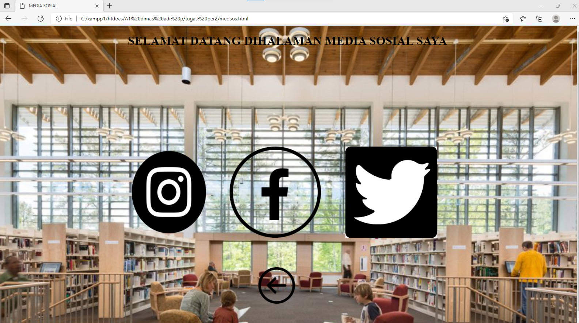

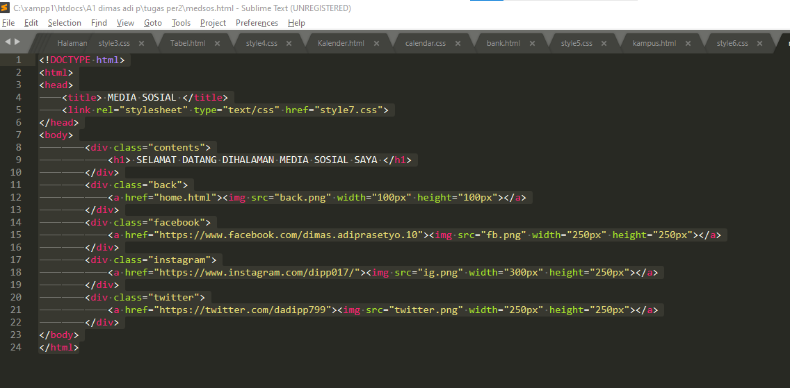

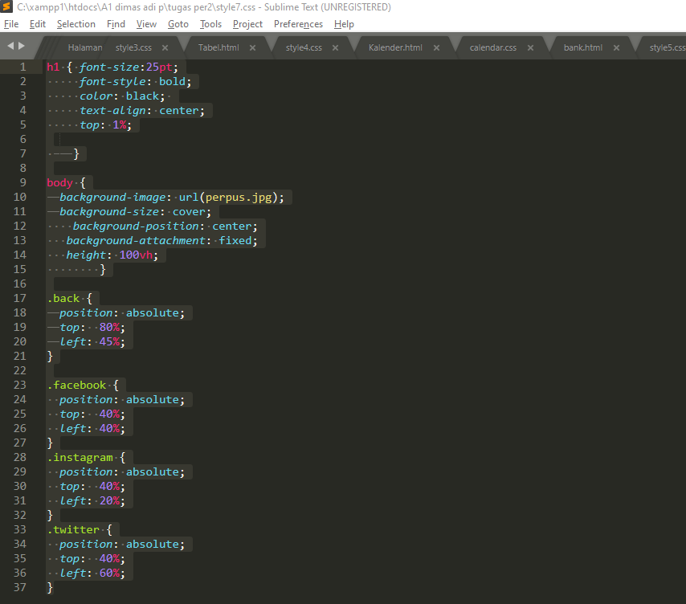

1. Halaman Biodata

biodata.html

Script

| <!DOCTYPE html>  <html>  <head>  <title> BIODATA </title>  <link rel="stylesheet" type="text/css" href="style8.css">  </head>  <body>  <div class="contents">  <h1> SELAMAT DATANG DIHALAMAN BIODATA SAYA </h1>  </div>  <div class="foto">  <img src="biodata.jpg" width="150px" height="200px">  </div>  <div class="tulisan">  <pre>  Nama : Dimas Adi Prasetyo  Tempat/Tanggal Lahir : Cirebon, 10 juli 1999  Jenis Kelamin : Laki-Laki  Agama : Islam  Kewarganegaraan : Indonesia  Alamat : Jl. Ujung Pandang no.1 Pondok Bambu  Nomor Telepon : 082112603636  Perguruan Tinggi : Universitas Krisnadwipayana  Fakultas : Teknik  Jurusan : Informatika  Hobi : Main Game  </pre>  </div>  </div>  <br><br><br><br><br><br>  <div class="back">  <a href="home.html"><img src="back2.png" width="100px" height="100px"></a>  </div>  </body>  </html> |
| --- |

style8.css

Script

| h1 { font-size:30pt;  font-style: bold;  color: white;  text-align: center;  top: 1%;  }  .foto {  position: absolute;  top: 15%;  left: 45%;  }  body {  background-image: url(bgbiodata.jpg);  background-size: cover;  background-position: center;  background-attachment: fixed;  height: 100vh;  }  .tulisan {text-align: justify;  position: absolute;  top: 40%;  left: 15%;  font-size:16pt;  font-style: bold;  color: white;  }  .back {  position: absolute;  top: 85%;  left: 47%;  } |
| --- |

Screenshot script dan hasil output

